UNIVERSITY INSTITUTE OF COMPUTING



PROJECT REPORT ON
CRIME PATTERN ANALYSIS USING DATA MINING
Program Name: BCA
Subject Name/Code: Minor Project(24CAR-309)

SUBMITTED TO: SUBMITTED BY:
NAME: MR. AMIT KUMAR NAME: AARTI

UID: 24BCA10622

SECTION:24BCA6-A

TABLE OF CONTENTS

Abstract

Graphical Abstract Abbreviations Symbols
Chapter 1. Introduction

  - Identification of Need / Contemporary Issue

  - Identification of Problem

  - Identification of Tasks

  - Timeline

  - Organization of the Report

Chapter 2. Literature Review / Background Study

  - Background and Development of the Problem

  - Existing Solutions

  - Comparative Review of Techniques

  - Review Summary

  - Problem Definition

  - Goals and Objectives Chapter 3. Design Flow / Process
  - Feature and Tool Selection

  - Design Constraints

  - Feature Analysis and Finalization

  - Design Flow

  - Design Selection

  - Implementation Plan / Methodology Chapter 4. Results Analysis and Validation
  - Implementation of Solution

  - Clustering Demonstration

  - Classification Evaluation

  - Regression Demonstration

  - Limitations and Validation Chapter 5. Conclusion and Future Work References
Appendix A. Execution Instructions Appendix B. User Manual

LIST OF FIGURES

Figure 3.1 Project workflow

Figure 4.1 Recorded classification demonstration metrics Figure 4.2 Recorded regression demonstration metrics

LIST OF TABLES

Table 1.1 Project tasks and outputs Table 1.2 Indicative project timeline
Table 2.1 Summary of reviewed approaches Table 3.1 Tools and their purpose
Table 4.1 Recorded demonstration metrics

ABSTRACT

Crime-related data can contain information about incident categories, time, location, and other characteristics. Data mining methods can help organize such information and explore possible patterns. This project presents a compact demonstration workflow combining K-Means clustering, Decision Tree classification, and Linear Regression. The implementation is written in Python and executed in Google Colab, while the report is formatted for academic submission. A synthetic dataset of 360 records is used so that the workflow can be tested without accessing restricted or sensitive police records. The prepared demonstration includes cluster summaries, classification metrics, a confusion matrix, and regression evaluation outputs. Recorded example classification metrics include 85.56% accuracy and an F1-score of 81.69%; recorded regression metrics include MAE of 2.5135, RMSE of 3.1899, and R-squared of 0.5567. These figures are specific to the synthetic demonstration and should not be interpreted as real-world crime forecasting performance. A future version should be evaluated on a suitable, ethically sourced public dataset with a clearly separated test set.
Keywords: crime pattern analysis, data mining, K-Means, Decision Tree, Linear Regression, synthetic data, visualization.

GRAPHICAL ABSTRACT

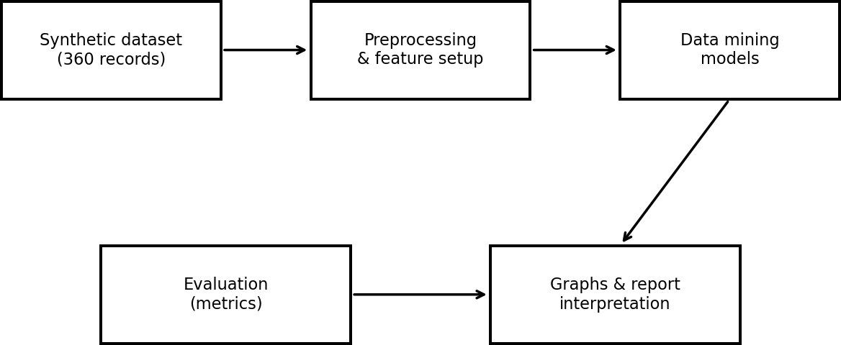

Figure GA.1. Overview of the project workflow. The dataset used in this demonstration is synthetic.

ABBREVIATIONS

Abbreviation | Meaning
AI | Artificial Intelligence
CSV | Comma-Separated Values
F1-score | Harmonic mean of precision and recall
MAE | Mean Absolute Error
RMSE | Root Mean Squared Error
UID | University Identification Number
PDF | Portable Document Format
R² | Coefficient of determination

SYMBOLS

n — Number of observations

k — Number of clusters in K-Means xᵢ — Feature vector for observation i ŷ — Predicted numerical value
y — Observed numerical value μⱼ — Centroid of cluster j
ε — Prediction error

CHAPTER 1. INTRODUCTION

Identification of Need / Relevant Contemporary Issue
Crime is a social issue that affects public safety and community well-being. Historical crime records may contain patterns related to incident type, time, or location. When such records are organized and analysed responsibly, they can help researchers understand data characteristics and formulate questions for further investigation. This project is an educational prototype that demonstrates data mining methods; it is not a decision-making system for policing and does not claim to identify actual crime hotspots.

Identification of Problem
The problem addressed is how to create a small, reproducible workflow that demonstrates several data mining methods on structured crime-like records. The workflow should be easy to run, provide understandable visual outputs, and report its limitations. Because real crime data may be restricted, sensitive, incomplete, or subject to access rules, the current implementation uses synthetic records.

Identification of Tasks
    - Review relevant literature on crime analysis and data mining.
    - Prepare a clearly labelled synthetic dataset for a controlled demonstration.
    - Implement K-Means clustering to group observations by selected features.
    - Implement Decision Tree classification and calculate evaluation metrics.
    - Implement Linear Regression and calculate numerical error metrics.
    - Generate graphs and tabular outputs for interpretation.
    - Document the workflow, limitations, and possible future improvements.

Timeline

Phase | Activity | Indicative duration
1 | Topic selection and reading  papers | Week 1

2 Dataset and Python
environment setup
Week 2

3 Implementation and
execution
Week 3

4 Graphs, metrics and
interpretation
Week 4

5 Report preparation and
review
Week 5

The timeline is an indicative planning outline. Replace it with the actual dates and progress approved by the project supervisor.

Organization of the Report
Chapter 1 introduces the need, problem, tasks, and schedule. Chapter 2 summarizes related work and existing approaches. Chapter 3 describes the tools, design choices, constraints, and methodology. Chapter 4 reports the recorded demonstration outputs and discusses their meaning and limitations. Chapter 5 presents the conclusion and future work. The appendices provide execution instructions and a short user manual.

CHAPTER 2. LITERATURE REVIEW / BACKGROUND STUDY

Background and Development of the Problem
Researchers have explored data mining as a way to analyse structured records and discover relationships that may not be obvious from manual inspection. Crime analysis can involve spatial and temporal summaries, clustering, classification, association analysis, and forecasting. The usefulness of any method depends on data quality, the target question, the validation design, and responsible interpretation.

Existing Solutions
Earlier studies have considered different approaches to crime analysis. Clustering methods group observations with similar feature values; classification methods assign records to predefined categories; and regression methods estimate numeric outcomes. Other studies have explored association rules and forecasting methods. No single technique is appropriate for every dataset, and model results should be compared against simple baselines.

Comparative Review of Techniques

Approach | Purpose | Potential strength | Important limitation
K-Means clustering | Group similar observations | Simple and efficient for numeric features | Requires choice of k; sensitive to scaling and outliers
Decision Tree | Classify records into labels | Interpretable decision rules | Can overfit; metrics depend on labels and test design
Linear Regression | Estimate numeric target | Simple baseline for numeric outcomes | Assumes a linear relationship and can underfit complex data
Visualization | Communicate patterns and outputs | Makes summaries easier to inspect | A graph alone does not prove a causal

relationship

Review Summary
The reviewed approaches suggest that clustering, classification, and regression address different analytical questions. The present project combines them in one educational workflow so that the outputs can be compared and explained. The implementation is a prototype rather than a validated operational forecasting system.

Problem Definition
The project aims to demonstrate how a small structured dataset can be processed with selected data mining algorithms and how their outputs can be summarized through metrics and graphs. It does not aim to infer individual criminality, make decisions about people, or establish real geographic crime risk. These uses would require separate legal, ethical, and empirical review.

Goals and Objectives
    - Create a reproducible Python workflow that runs in a notebook environment.
    - Demonstrate K-Means, Decision Tree, and Linear Regression on synthetic records.
    - Generate visual summaries and numerical evaluation measures.
    - Explain the assumptions and limitations of the chosen methods.
    - Outline how the prototype could later be evaluated using an appropriate public dataset.

CHAPTER 3. DESIGN FLOW / PROCESS

Evaluation and Selection of Specifications / Features
The project was designed to be lightweight, understandable, and reproducible. Python was selected because it supports data handling, machine learning, and plotting through widely used libraries. Google Colab was used as the execution environment so that setup could be performed in a browser. The synthetic CSV provides structured input without requiring access to private records.

Design Constraints
    - Data constraint: synthetic records do not represent real incidents or population patterns.
    - Computational constraint: the workflow is designed for a small notebook-scale experiment.
    - Validation constraint: demonstration metrics are not evidence of performance on unseen real data.
    - Ethical constraint: outputs must not be used to target individuals or make operational policing decisions.
    - Reproducibility constraint: package versions and the dataset should be recorded for repeatable runs.

Analysis of Features and Finalization Subject to Constraints
The selected methods represent three different task types: unsupervised grouping, supervised classification, and numerical regression. The features and target labels in a synthetic dataset are chosen for demonstration rather than because they have been validated as meaningful predictors of real crime. Before using real data, the features, missing-value handling, scaling, label definitions, and data permissions would need to be reviewed.

Design Flow

Figure 3.1. Workflow for the synthetic-data demonstration.

Design Selection
A combined workflow was selected because it demonstrates multiple analytical tasks while keeping the implementation manageable. An alternative would be to implement only one algorithm, which would be simpler but would not illustrate the differences between clustering, classification, and regression. A second alternative would be to use real public data; this may improve practical relevance but requires careful source verification, data cleaning, documentation, and ethical review.

Implementation Plan / Methodology
- Load the synthetic CSV dataset into a Python data frame.
- Inspect columns and prepare features required by each algorithm.
- Apply K-Means to group observations and summarize the clusters.
- Train and evaluate a Decision Tree classifier using the script's configured evaluation procedure.
- Fit Linear Regression and calculate MAE, RMSE, and R² for the configured target.
- Save graphs and CSV summaries to the output directory.

- Review outputs and clearly report that the experiment uses synthetic data.

Tools and Their Purpose

Tool / library | Purpose
Google Colab | Browser-based Python execution
Python | Implementation language
pandas | Reading and managing tabular data
NumPy | Numerical operations
scikit-learn | Clustering, classification, regression, metrics
Matplotlib | Creating graphs
Overleaf / LaTeX | Preparing the research paper source and PDF

CHAPTER 4. RESULTS ANALYSIS AND VALIDATION

Implementation of Solution
The project package contains a Python script named crime_analysis.py, a synthetic CSV dataset, supporting figures, and a LaTeX source file. The script can be run in Google Colab or another Python environment after installing the required packages. The main outputs include cluster summaries, classification metrics, a confusion matrix, regression metrics, and plots.

Clustering Demonstration
K-Means assigns each observation to the nearest cluster centroid and updates centroids iteratively. In this project, the clustering output is intended to demonstrate how numeric feature vectors can be grouped. Because the records are synthetic, the groups should not be interpreted as real crime hotspots.

Classification Evaluation
The Decision Tree classifier produces a predicted category for each evaluated observation. Common evaluation measures include accuracy, precision, recall, and F1-score. Accuracy measures the proportion of correct predictions; precision measures how many predicted positive cases are correct; recall measures how many actual positive cases are identified; and the F1-score combines precision and recall.
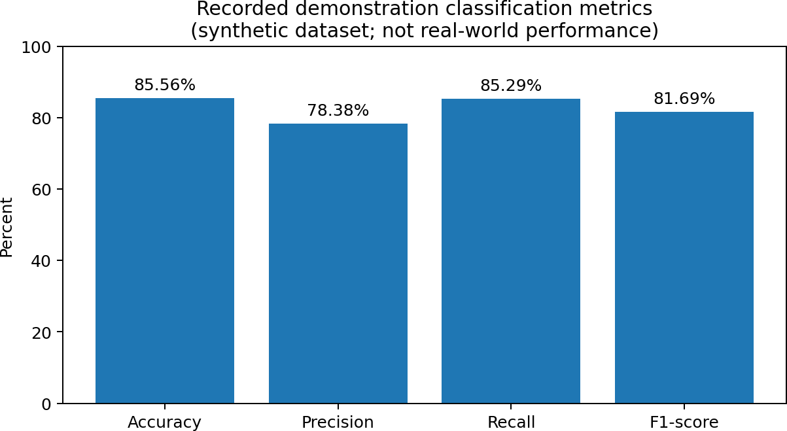

Figure 4.1. Recorded demonstration classification metrics on synthetic data.

Metric | Recorded demonstration value
Accuracy | 85.56%
Precision | 78.38%
Recall | 85.29%
F1-score | 81.69%

These values are recorded example outputs for the prepared synthetic-data demonstration. They should be verified against the current execution output before final submission and must not be presented as performance on real crime data.

Regression Demonstration
Linear Regression estimates a numeric target using a linear relationship between the selected input features and the target. Mean Absolute Error (MAE) and Root Mean Squared Error (RMSE) describe prediction error in the target's units, while R-squared describes the proportion of target variation accounted for by the fitted model in the evaluated data. Their interpretation depends on the target definition and evaluation design.
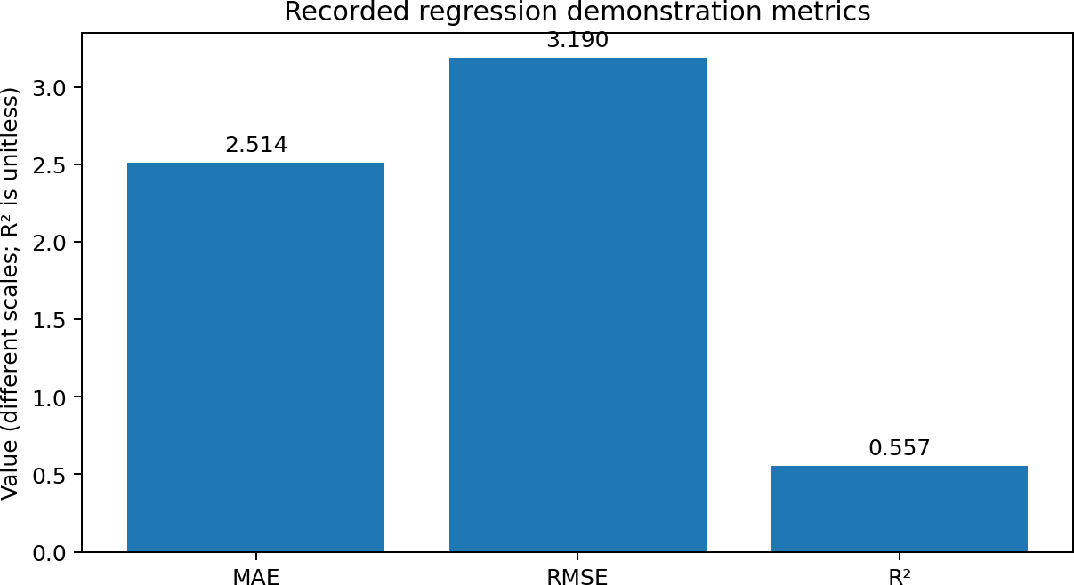

Figure 4.2. Recorded regression demonstration metrics. Values use different scales; R² is unitless.

Metric | Recorded demonstration value
MAE | 2.5135
RMSE | 3.1899
R² | 0.5567

Limitations and Validation
The central limitation is the use of synthetic data. The data are not collected from police records and cannot establish actual crime patterns. The metrics are therefore illustrative. A stronger validation study would use an ethically sourced and documented public dataset, separate training and test data, compare against baseline methods, inspect class imbalance, document preprocessing, and assess possible geographic or demographic bias. Results should be interpreted by qualified people and should not be used to make decisions about individuals.

CHAPTER 5. CONCLUSION AND FUTURE WORK

Conclusion
This project presents an educational workflow for exploring crime-like structured data with selected data mining methods. K-Means demonstrates grouping, Decision Tree demonstrates classification, and Linear Regression demonstrates numerical estimation. Python libraries support the implementation and visualization, while Overleaf is used to prepare the report in LaTeX. The project provides a reproducible starting point for learning about the workflow, but its synthetic dataset means the results do not demonstrate real-world crime forecasting capability.

Future Work
    - Replace the synthetic data with a verified, legally usable public dataset.
    - Document the data source, collection period, fields, and missing-value treatment.
    - Use a separate test set or time-based validation appropriate to the prediction task.
    - Compare models with simple baselines and report uncertainty where possible.
    - Investigate class imbalance, geographic bias, and the limits of interpreting correlations.
    - Improve visualizations and provide a reproducible requirements file and execution log.

REFERENCES
C.-H. Yu, M. W. Ward, M. Morabito, and W. Ding, “Crime Forecasting Using Data Mining Techniques,” in Proceedings of the IEEE International Conference on Data Mining Workshops, 2011, pp. 779–786, doi: 10.1109/ICDMW.2011.56.
S. Sathyadevan, D. M. S., and S. Gangadharan, “Crime Analysis and Prediction Using Data Mining,” in Proceedings of the First International Conference on Networks & Soft Computing, 2014, pp. 406–412.
U. Thongsatapornwatana, “A Survey of Data Mining Techniques for Analyzing Crime Patterns,” in Proceedings of the International Conference on Advanced Computing and Data Science (ACDT), 2016.
S. Yadav, M. Timbadia, A. Yadav, R. Vishwakarma, and N. Yadav, “Crime Pattern Detection, Analysis & Prediction,” in Proceedings of the International Conference on Electronics, Communication and Aerospace Technology (ICECA), 2017, pp. 225–230.
Note: Confirm each reference's exact bibliographic details against the original paper or publisher record before submission.

APPENDIX A. EXECUTION INSTRUCTIONS
The following instructions describe the intended workflow in Google Colab. File names and paths may differ depending on how the ZIP was uploaded.
- Open Google Colab and create a new notebook.
- Upload the project ZIP file using the Files panel or files.upload().
- Extract the ZIP using Python's zipfile module.
- Install or verify the required libraries: pandas, numpy, matplotlib, and scikit-learn.
- Locate crime_analysis.py and run it from its containing directory.
- Check the console output for errors and confirm the process exits with code 0.
- Inspect the generated PNG graphs and CSV result files. Verify the outputs before copying metrics into the report.
Example library installation command:

!pip install pandas numpy matplotlib scikit-learn

Example script execution pattern:

import os, sys, subprocess

script_path = None
for root, dirs, files in os.walk('/content/crime_project'): if 'crime_analysis.py' in files:
script_path = os.path.join(root, 'crime_analysis.py') break

if script_path:
result = subprocess.run( [sys.executable, script_path], cwd=os.path.dirname(script_path)
)
print('Exit code:', result.returncode) else:
print('Python script not found')

APPENDIX B. USER MANUAL

Purpose
This manual explains how to open the project, run the Python script, and locate the output files. The exact interface may change depending on the Colab version.

Input files
    - crime_analysis.py — main Python analysis script.
    - synthetic_crime_data.csv — synthetic demonstration records.
    - requirements.txt — required Python packages.
    - figures/ — packaged figures for the report.
    - main.tex — LaTeX source for the paper.
    - results/ — packaged CSV result summaries, if included in the archive.

Output files
The script is expected to create output plots and tabular files. PNG files are image outputs; CSV files contain data or evaluation summaries. Check the script's output directory and the printed messages to confirm where the files were saved.

Troubleshooting
    - FileNotFoundError: check the uploaded ZIP name and extracted folder path.
    - ModuleNotFoundError: install the missing package listed in requirements.txt.
    - No graphs found: confirm the script ran successfully and check its output directory.
    - Different metrics: use the current run's verified results and update the report accordingly.

Ethical and academic note
The included data are synthetic. Do not describe them as real police records. Replace placeholders on the cover and certificate pages, confirm citations, verify all results, and follow the university's project submission and originality requirements.

Supervisor approval: Date:

